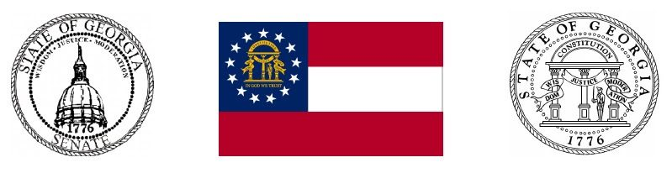

Senator

John Albers
Summer 2022 Newsletter

Website

Welcome
We are halfway through 2022 and it is good to see normalcy return after the pandemic. We are blessed to live in Georgia and I am very proud of Governor Brian Kemp and my fellow legislators for our proactive work to stay the #1 place to live, work, play and raise a family.
Our family is having a terrific 2022 and we are very proud of our boys. Please consider enjoying vacations in Georgia and support our local businesses. Thank you for giving me the opportunity to continue serving you.

Independence Day
On this day 246 years ago, a group of patriots conceived a new nation which would become the beacon of freedom and liberty for the world. The United States of America is our country, she has endured through history using the fundamental beliefs and words created by our founding fathers.
Please take time to read and understand our Declaration of Independence and Constitution. These timeless documents were divinely inspired and the remain foundation of America. From the Albers family to yours, we wish you a Happy Independence Day!

Transplant one year later...
On July 21, 2021 my son Will and I walked in to Emory Hospital at 5:00 am. It all started in August of 2020, our oldest Will was rushed to the hospital, and we quickly learned he was in kidney failure. We almost lost him and we are so grateful to the doctors, nurses and staff at Northside Cherokee Hospital. Praise the Lord he survived, but needed to go on dialysis at 24 years old. Our world was forever changed, and the impact was substantial for Will and our family.
In early July of 2021, we received the most anticipated and greatest news… I WAS THE MATCH to donate a kidney to Will! I cannot fully describe the emotion of hearing from the medical team at Emory Hospital after months of tests. We asked people to please pray for Will, me, our family and the medical staff.
Along the way, God sent angels to help light the path ahead. We have kept our situation quiet at first and felt it was important to share the story. Our hope is people will get tested if they are feeling ill, have a network to understand kidney disease, support those in need, learn their family history and learn about being a transplant donor. We know God had a plan and our mission is now to share our experience and serve others.
The outpouring of support was heartwarming, and more than words can describe. Will accepted my kidney and we both recovered quickly. Thank you to our worldwide prayer army. There is goodness all around us and we are grateful and healthy one year later...

Georgia Economy Soars Despite Massive Federal Inflation
It is hard to imagine that we are now just over two years removed from the state lifting restrictions placed on Georgia’s businesses to curb the spread of COVID-19. At the time, there was a lot of uncertainty surrounding the virus and many state governments were paralyzed by indecision over how to regulate their businesses. However, Governor Brian Kemp and other Georgia leaders saw that a pathway existed for our state to open back up for business in a safe and responsible manner. There were many who were quick to cast doubt on Gov. Kemp for opening Georgia up to business so soon. There were calls that it would lead to an economic disaster or that it would set us back even further. The truth, as it turns out, is that the opposite was true. Georgia not only maintained a healthy economy since opening up, we have flourished. As such, our state became a national model on how to navigate the pandemic safely while ensuring our state’s critical small businesses could remain in operation.
While our counterparts in Washington DC have mismanaged so much, in Georgia we continue to defy all the odds by doing the right thing. Georgia is the best place to live!
Today, two years separate us from the height of the pandemic, there are some who would be astonished at all that Georgia has been able to accomplish. Other states in took a different path with ongoing lockdowns and misrepresented political bias. Thankfully in Georgia the steady, consistent conservative leadership is the reason our economy has remained resilient and vibrant all through the uncertainty of the pandemic. Gov. Brian Kemp and his team continue to perform an outstanding job standing up for our small businesses and reducing hurdles that prevent them from thriving. Without leadership from the top, we may not have been able to enjoy the strong economy we have today.

Champion of Public Safety
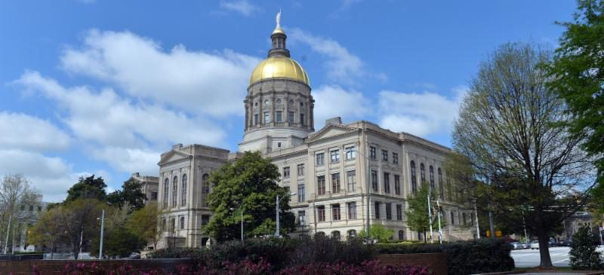
Website

